Image Attractiveness prediction model based on Click Through Rate (CTR)

1)Objective:

1. To extract multimedia features from advertisement images for prediction model.
2. To create a robust prediction model to predict click through rate (CTR).

2)Introduction:

To run a mobile advertisement campaign, it is important to publish a right image to attract user to click on the advertisement. One of the most popular measurement use for advertiser is click through rate (CTR). CTR is the ratio of number of users click on ad divided by numbers of times ads is shown. Higher CTR means the campaign had attract more user to the website. Compared to the traditional ways of running an advertisement campaign is by an experience person to judge attractive images which tend to be bias and time consuming. A predictive model help advertiser company advertise a right image that will attract more user to visit a website. To build a robust prediction model, a historical data is essential for training the model.

3)Methodology:

Below flowchart shows the steps to build prediction model and further explain in the sub-section

Feature Extraction

(global, local, high level)

Prediction Model

Feature Selection

Input data (image URL)

3.1)Data:

The Facebook advertisement image URL is in a SUKI system which is manage by Adparlor Thailand. The Fb ad image URL is at level 1 of the campaign hierarchy. Adparlor team (Hong and Earth) had agreed to pump in the data into our AWS s3 every 2nd day of each month. Figure 1 show the campaign hierarchy and figure2 show the SUKI data in aws bucket name ada-adset. To build a prediction graph, image feature and measurement metric is needed. Image feature will be explain feature in next subsection. Measurement metric is in fbInsight.json file in aws ada-adset bucket and creative url in in fbcreatives.json file. All of these file is link by the same account ID. The link of data is as below:

<https://s3.console.aws.amazon.com/s3/buckets/ada-adset/?region=us-east-1&tab=overview>





Figure 1: campaign hierarchy.



Figure2: fbcreatives data in ada-adset bucket in aws s3

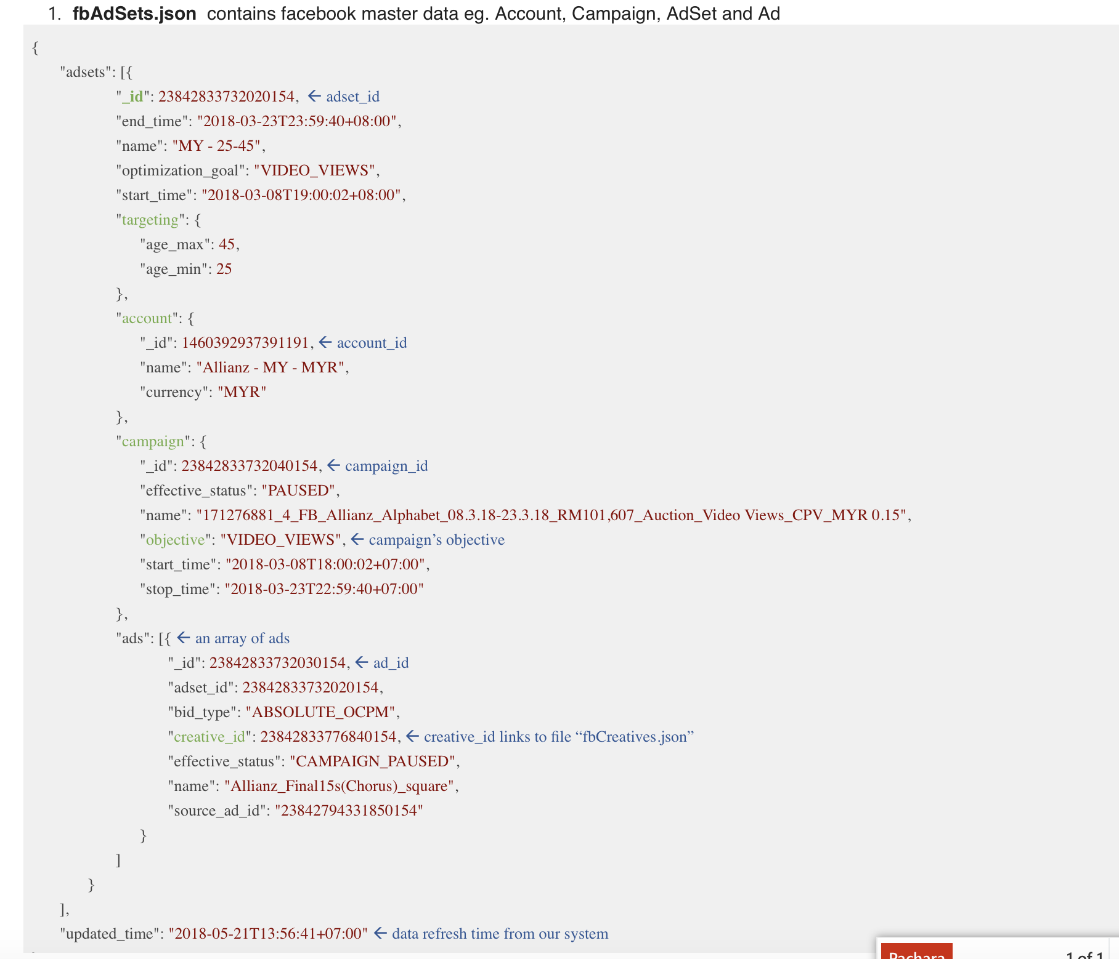

Figure 3: fbAdSets file

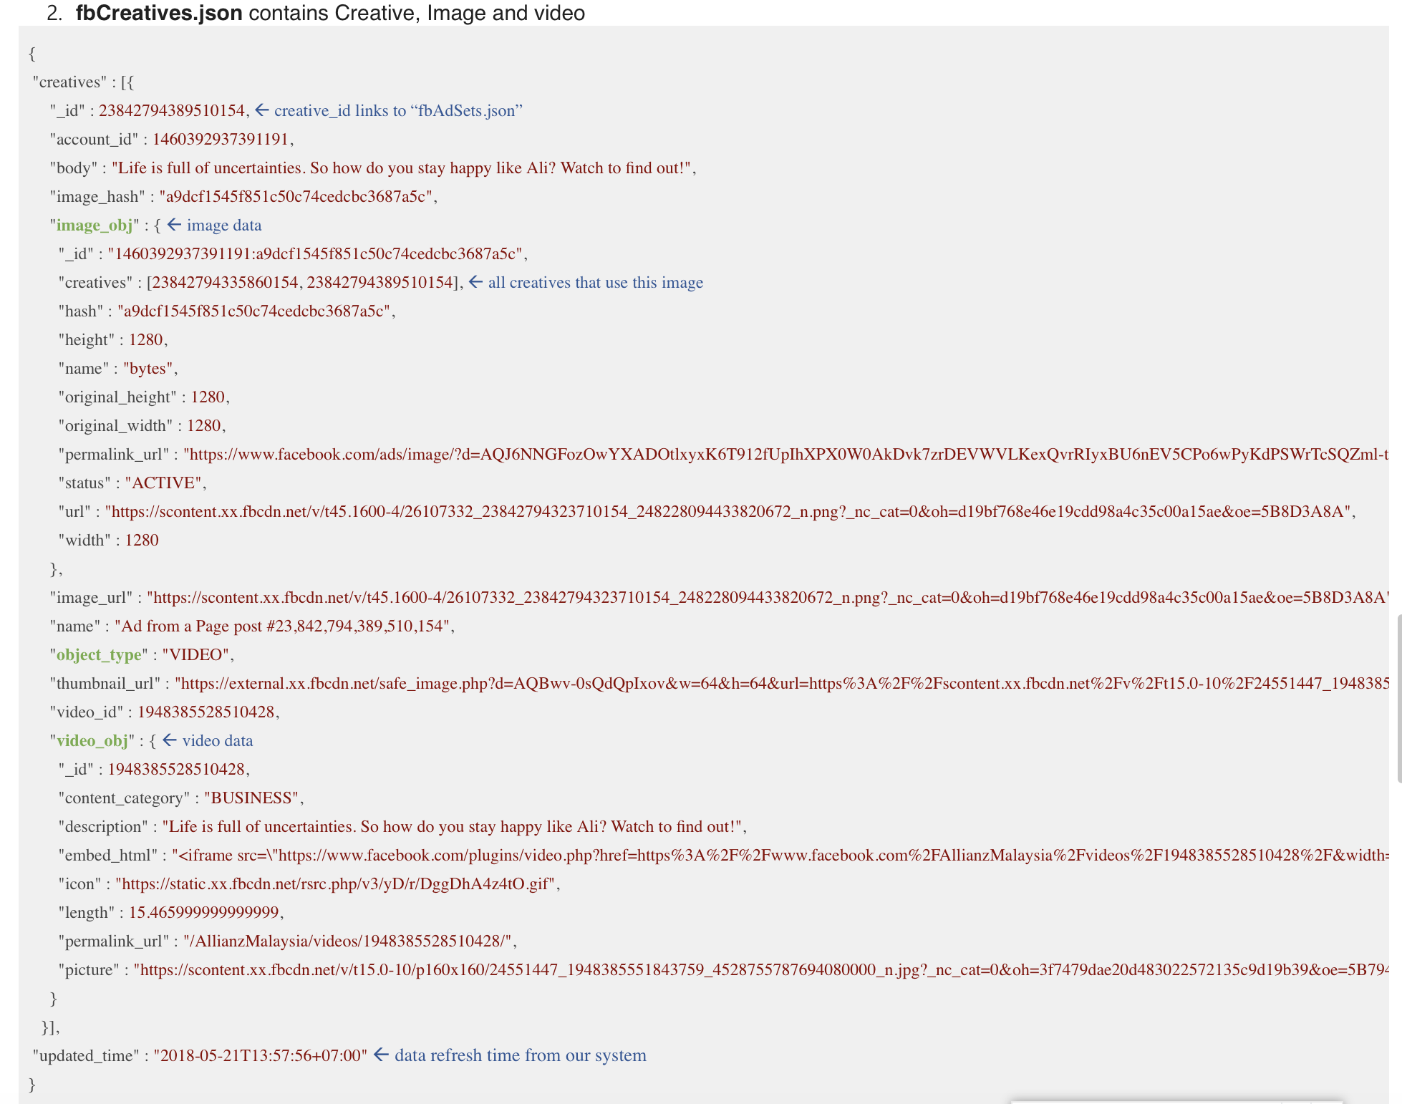

Figure 4: fbCreatives file contain creative url

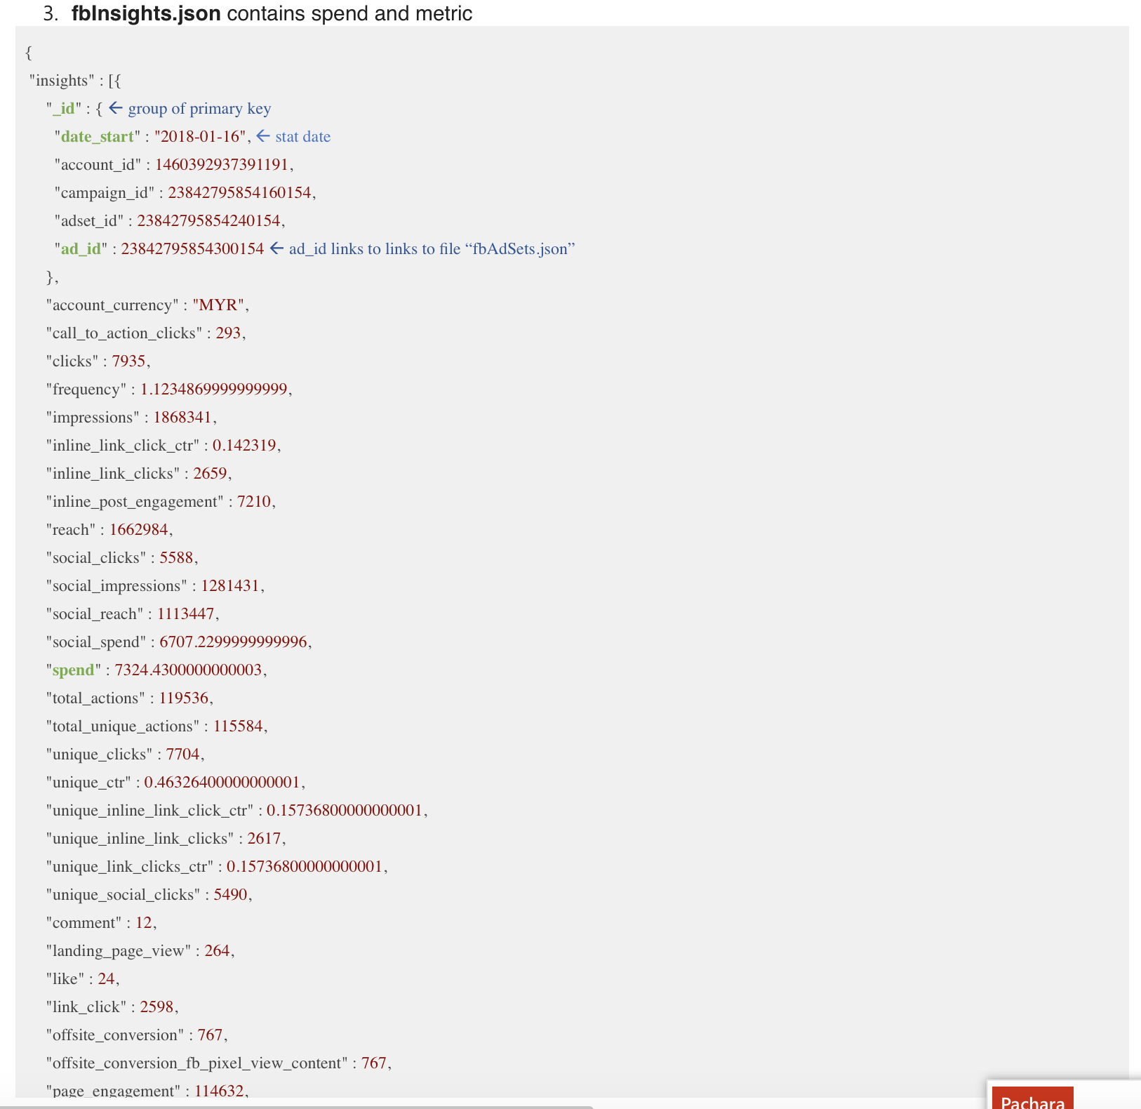

Figure 5: fbInsights contain measurement matric for the advertisement

3.2) Feature extraction:

Image feature can be divided into three categories; global, local and high level feature. Up until this documentation is written, 6 global feature has been successfully extracted and list as below:

1. Brightness:

* RGB image need to be converted to YUV color space where Y array is defined as the brightness. From Y array, the average, standard deviation, maximum and minimum is take as a brightness feature.

1. Saturation:

* Saturation is defined by the HLS color space, where S array from HLS represent saturation. For S array, average, standard deviation, maximum and minimum is take as saturation feature.

1. Colorfulness:

* Is a measure of difference between color image to gray.

1. Contrast:

* Standard deviation of the luminance (brightness) of all image pixels. Then calculate the SD of the normalized luminance of all image pixels.

1. Sharpness:

* Determine by Laplacian function, then normalized by the local average luminance in the surrounding of each pixel.

1. Texture:

* Extract texture contrast, energy, homogeneity, correlation, dissimilarity and ASM define by grey level co-occurrence matrix (GLCM) method